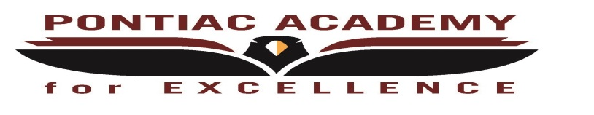
Pontiac Academy for Excellence
Extended COVID-19 Learning Plan Reconfirmation for December
Board Meeting held: Tuesday, February 16, 2021

Reconfirm instructional delivery method:
Pontiac Academy for Excellence’s instructional delivery is Virtual
Reconfirm how instruction will be delivered for each grade level
Elementary (Grades K - 5):
Instructional delivery is virtual

Middle School (Grades 6 - 8):
Instructional delivery is virtual

High School (Grades 9 - 12):
Instructional delivery is virtual

Reconfirm whether or not the district is offering higher levels of in-person instruction for English language learners, special education students, or other special populations:
Pontiac Academy for Excellence’s instructional delivery is Virtual
Document Public Comments:
None

Review Weekly 2-Way Interaction Rates
February 2021 | All Students K-12
Week 1 | 100%
Week 2 | 100%
Week 3 | Not Available
Week 4 | Not available

